**Parallel and Distributed Systems**

**Assignment – 5**

**SID : 004507888**

Open MP program has been used to find the sum of the array. We have used the array sizes in 2 to the power. We have the readings for 2 to the power 8,10,12,14,16,18.To generate the reading run the shell script exe.sh. it will generate the data file for the aforementioned sizes. It can be done manually after compilation without using the shell script as below.

To Compile: gcc -fopenmp -lm -o main main.c

To Run : ./main <power of the size of the array>

Each of the graphs obtained in the GNU plot as below. The GNU script file is named script.txt. to generate a plot using this script file, make sure the corresponding data file is present and issue the command

“gnuplot -c script.txt <power of the array>”

Plots :

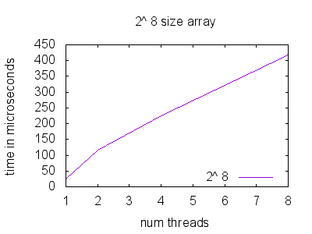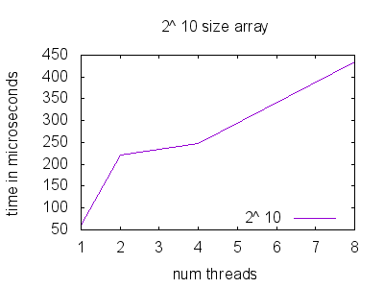

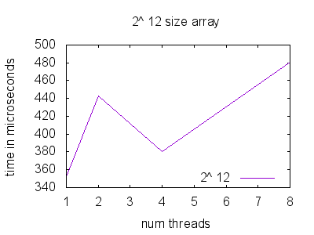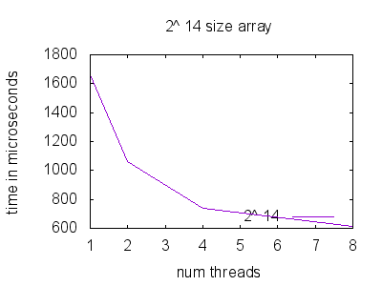

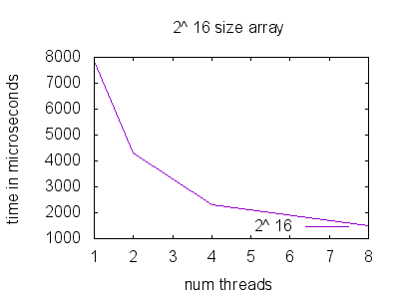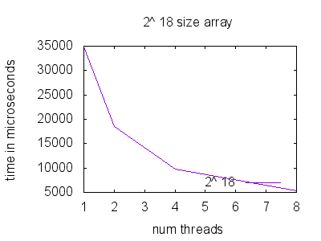

From the above plots we can observe that for the lower order arrays the execution time increase as the number of the threads increases. This is because we are having a less computational problem distributed among many threads which makes the communication expensive. As we increase the size from 14 and above, we can see that as the number of threads increase the speedup increases.

The plots for the speed ups:

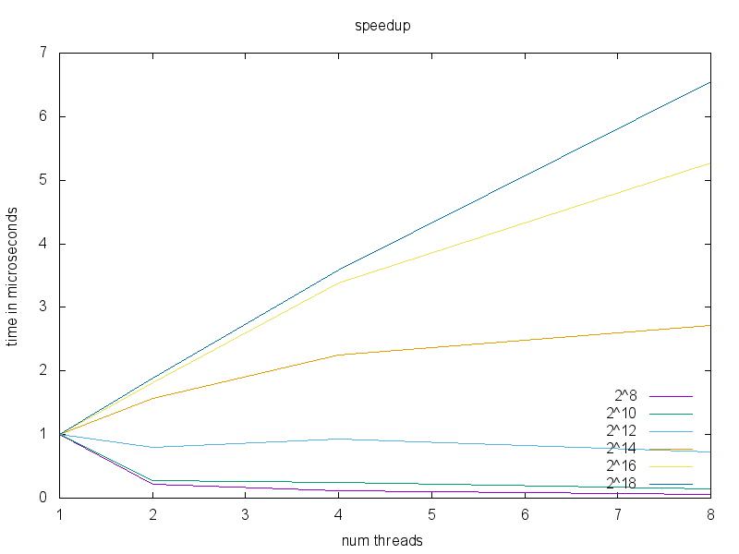

As we can see form the plot as the size of the array increase the communication cost goes down compared to the computation cost and speed up us achieved.